Symbole

Im Fließtext:
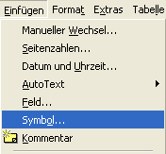
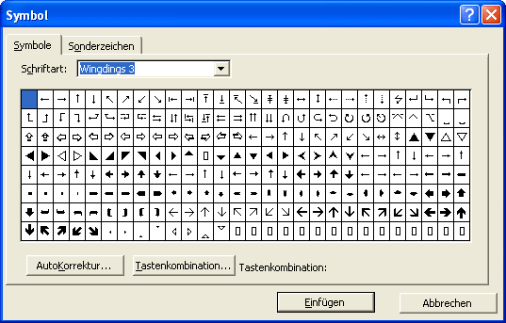
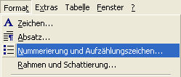
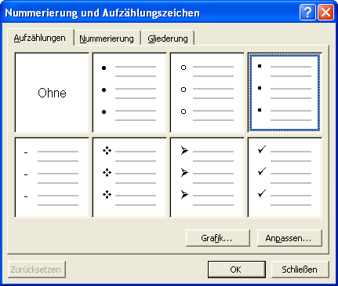
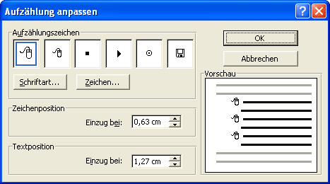
z.B.  Graben 1, 1010 Wien  01/2345678

In einer Aufzählung:
 Wählen Sie hier die Schriftart Wingdings bzw. Webdings(1,2,3).
z.B.
- Forest Gump
- Der Schuh des Manitu
- James Bond

 Beachten Sie auch die Registerkarte "Sonderzeichen"! Hier findet man z.B. das Copyright ©, ® oder den geschützen Trennstrich.

Webdings
 |  |  |  |  |  |  |  |  |  |  |  |  |  |  |  |  |  |  |  |  |  |  |  |  |  |  | 
 |  |  |  |  |  |  |  |  |  |  |  |  |  |  |  |  |  |  |  |  |  |  |  |  |  |  | 
 |  |  |  |  |  |  |  |  |  |  |  |  |  |  |  |  |  |  |  |  |  |  |  |  |  |  | 
 |  |  |  |  |  |  |  |  |  |  |  |  |  |  |  |  |  |  |  |  |  |  |  |  |  |  | 
 |  |  |  |  |  |  |  |  |  |  |  |  |  |  |  |  |  |  |  |  |  |  |  |  |  |  | 
 |  |  |  |  |  |  |  |  |  |  |  |  |  |  |  |  |  |  |  |  |  |  |  |  |  |  | 
 |  |  |  |  |  |  |  |  |  |  |  |  |  |  |  |  |  |  |  |  |  |  |  |  |  |  | 
 |  |  |  |  |  |  |  |  |  |  |  |  |  |  |  |  |  |  |  |  |  |  |  |  |  |  | 

Wingdings
 |  |  |  |  |  |  |  |  |  |  |  |  |  |  |  |  |  |  |  |  |  |  |  |  |  |  | 
 |  |  |  |  |  |  |  |  |  |  |  |  |  |  |  |  |  |  |  |  |  |  |  |  |  |  | 
 |  |  |  |  |  |  |  |  |  |  |  |  |  |  |  |  |  |  |  |  |  |  |  |  |  |  | 
 |  |  |  |  |  |  |  |  |  |  |  |  |  |  |  |  |  |  |  |  |  |  |  |  |  |  | 
 |  |  |  |  |  |  |  |  |  |  |  |  |  |  |  |  |  |  |  |  |  |  |  |  |  |  | 
 |  |  |  |  |  |  |  |  |  |  |  |  |  |  |  |  |  |  |  |  |  |  |  |  |  |  | 
 |  |  |  |  |  |  |  |  |  |  |  |  |  |  |  |  |  |  |  |  |  |  |  |  |  |  | 
 |  |  |  |  |  |  |  |  |  |  |  |  |  |  |  |  |  |  |  |  |  |  |  |  |  |  | 

Wingdings 2
 |  |  |  |  |  |  |  |  |  |  |  |  |  |  |  |  |  |  |  |  |  |  |  |  |  |  | 
 |  |  |  |  |  |  |  |  |  |  |  |  |  |  |  |  |  |  |  |  |  |  |  |  |  |  | 
 |  |  |  |  |  |  |  |  |  |  |  |  |  |  |  |  |  |  |  |  |  |  |  |  |  |  | 
 |  |  |  |  |  |  |  |  |  |  |  |  |  |  |  |  |  |  |  |  |  |  |  |  |  |  | 
 |  |  |  |  |  |  |  |  |  |  |  |  |  |  |  |  |  |  |  |  |  |  |  |  |  |  | 
 |  |  |  |  |  |  |  |  |  |  |  |  |  |  |  |  |  |  |  |  |  |  |  |  |  |  | 
 |  |  |  |  |  |  |  |  |  |  |  |  |  |  |  |  |  |  |  |  |  |  |  |  |  |  | 
 |  |  |  |  |  |  |  |  |  |  |  |  |  |  |  |  |  |  |  |  |  |  |  |  |  |  | 

Wingdings 3
 |  |  |  |  |  |  |  |  |  |  |  |  |  |  |  |  |  |  |  |  |  |  |  |  |  |  | 
 |  |  |  |  |  |  |  |  |  |  |  |  |  |  |  |  |  |  |  |  |  |  |  |  |  |  | 
 |  |  |  |  |  |  |  |  |  |  |  |  |  |  |  |  |  |  |  |  |  |  |  |  |  |  | 
 |  |  |  |  |  |  |  |  |  |  |  |  |  |  |  |  |  |  |  |  |  |  |  |  |  |  | 
 |  |  |  |  |  |  |  |  |  |  |  |  |  |  |  |  |  |  |  |  |  |  |  |  |  |  | 
 |  |  |  |  |  |  |  |  |  |  |  |  |  |  |  |  |  |  |  |  |  |  |  |  |  |  | 
 |  |  |  |  |  |  |  |  |  |  |  |  |  |  |  |  |  |  |  |  |  |  |  |  |  |  | 
 |  |  |  |  |  |  |  |  |  |  |  |  |  |  |  |  |  |  |  |  |  |  |  |  |  |  | 

